**Introduction - This research program focuses on enabling public participation in science and technology topics and facilitating the communication between experts and ordinary citizens.**



Science and Technology topics (e.g., pandemics, climate change, gene editing, artificial intelligence) have increasingly becoming the focus of public discussion. Public understanding of science and technology is the foundation of the governance of these history-changing actants. Without the publics’ buy-in, we cannot harvest the fruits of scientific breakthroughs (e.g., vaccine take-up). Without the public’s support, we won’t be able to reverse the climate change human development has induced. Without the public’s debate, we won’t know that there are limits the mankind must set to their own imagination (e.g., gene editing). Without the public’s thought evolvement, we cannot justify the decisions on technological development made by experts (e.g., artificial intelligence).

**Collaborators**

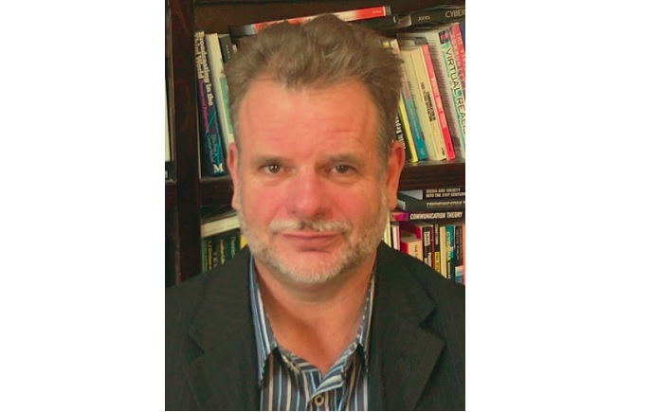

[Dr. David Holmes](https://research.monash.edu/en/persons/david-holmes)

Co-PI; Founder and Director, Climate Change Communication Research, Monash University

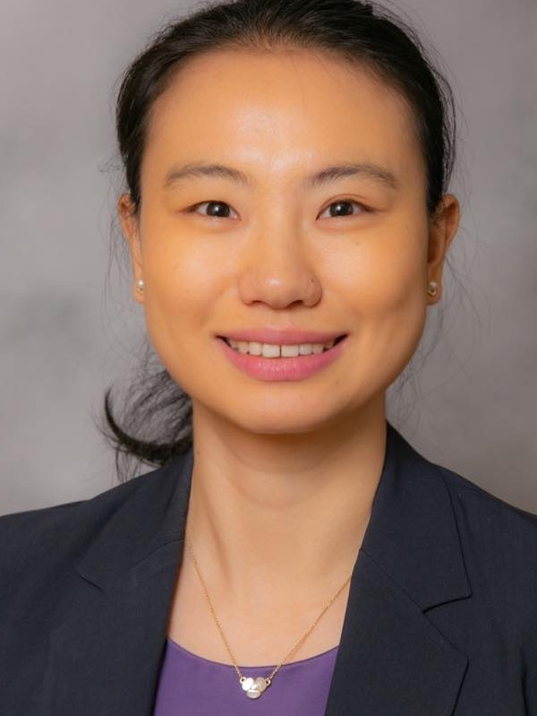

[Dr. Rong Wang](https://comm.uky.edu/people/wang)

Co-PI; Assistant Professor, Department of Communication, University of Kentucky

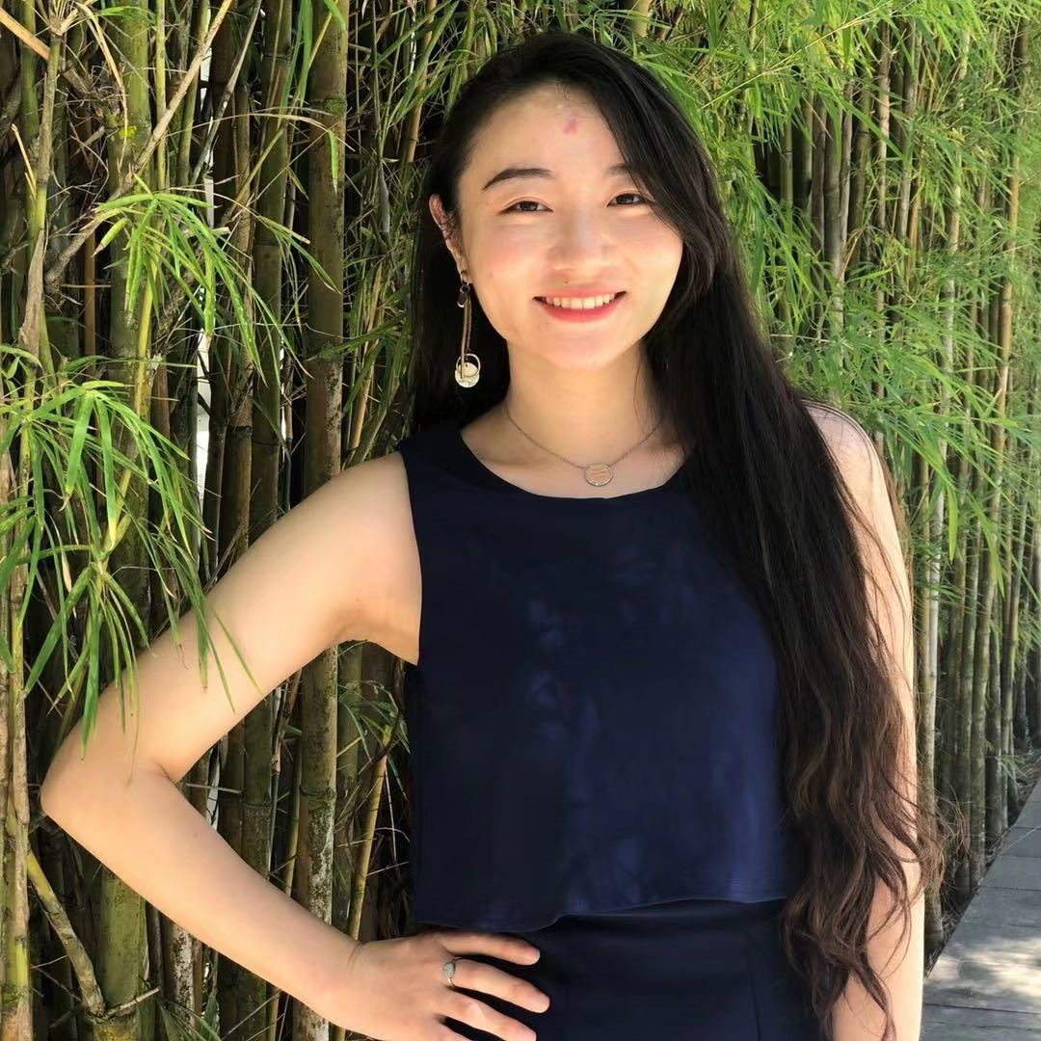

[Manjiang He](https://www.linkedin.com/in/manjianghe/)

Research Assistant, Master Student, LKYSPP, NUS



Xing Zhang

Research Assistant, PhD Student, CNM, NUS



[Ximing Liu](https://www.linkedin.com/in/ximing-liu-951543b8/?originalSubdomain=cn)

Research Assistant, Master student; currently Market Researcher at Tencent

  
Jingjing Liang

Research Assistant, Master student; currently taking a break



[Dr. Anfan Chen](https://www.researchgate.net/profile/Anfan-Chen)

Visiting PhD Student, Tsinghua University, 2019; currently PostDoc Researcher at Chinese University of Hong Kong (CUHK)

**Kehan Yang**

Research Assistant, Master Student, LKYSPP, NUS

Haodong Liu

Research Intern; currently Master graduate, City University of Hong Kong

**Publications**

1. Zhang, W., Chua, G., See, C. (July 2021). *The Role of Social Media in China’s Lifeworld Environmentalism*, paper presented at the 2021 Annual Conference of International Association of Media and Communication Research, virtual due to Covid-19. [video]
2. Zhang, X., Chen, A., & Zhang, W. (online first). [Before and after the Chinese gene-edited human babies: Multiple discourses of gene editing on social media.](https://doi.org/10.1177%2F0963662520987754) *Public Understanding of Science*. [video]
3. Liang, J., Liu, X., Zhang, W. (2019) [Scientists vs. Laypeople: How Genetically Modified Food is Discussed on a Chinese Q&A Website?](https://doi.org/10.1177%2F0963662519876782). *Public Understanding of Science, 28*(8), 991-1004.

Partner Institutions

This research was funded by International Universities Climate Alliance through the leadership of the Monash Climate Change Communication Research Hub and the Vaccine Confidence Fund by Facebook and Merck.

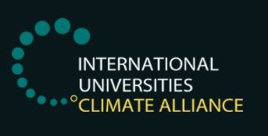

[The Monash Climate Change Communication Research Hub](https://www.monash.edu/mcccrh/home)



